|  |  |
| --- | --- |
| **North South University**  Department of Electrical & Computer Engineering  **LAB REPORT**  Course Code : EEE/ETE 241 L  Course Title: Electrical Circuit 2  Course Instructor: NNP  Experiment Number: 07  Experiment Name:  Measurement and Calculation of Power in AC Circuits  Date of Experiment: 4th of May, 2020  Date of Submission: 5th of May, 2020  Section: 02  Group Number: 04 | |
| Submitted By | Score |
| |  |  |  | | --- | --- | --- | |  | Student Name | ID | | **1.** | Tasmia Khanom | 1931843043 | | **2.** | Kaniz Fatema | 1520064045 | | **3.** | Mohammed Mahmudur Rahman | 1520386043 | |  |

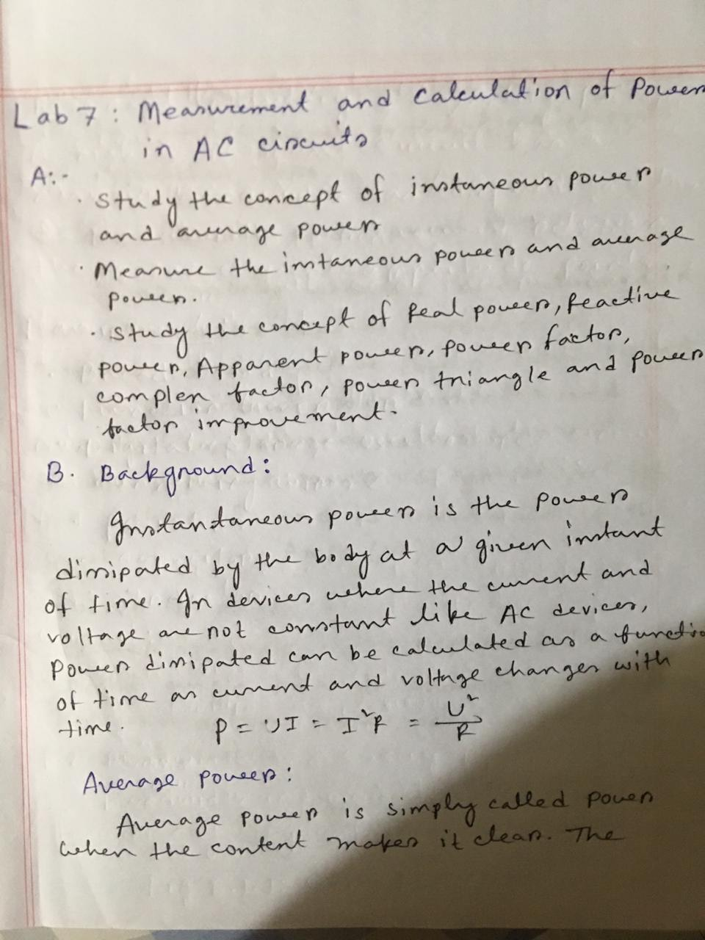

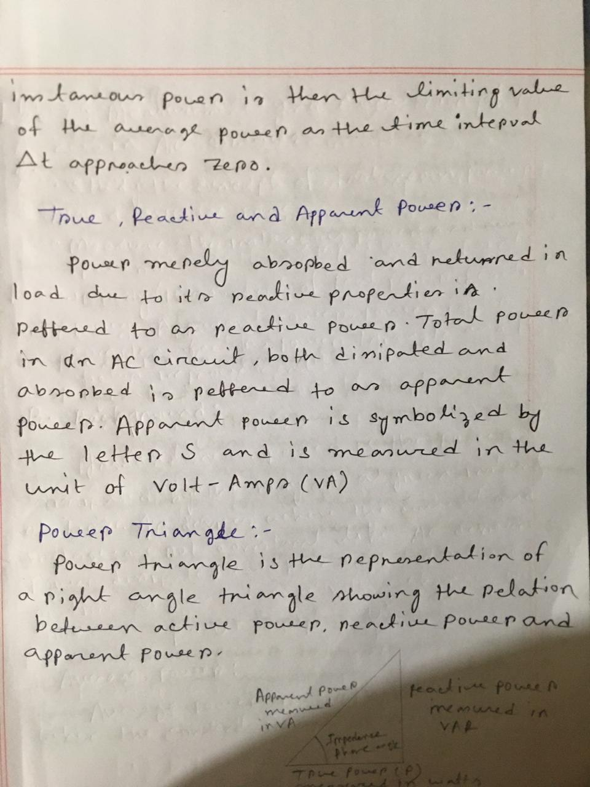

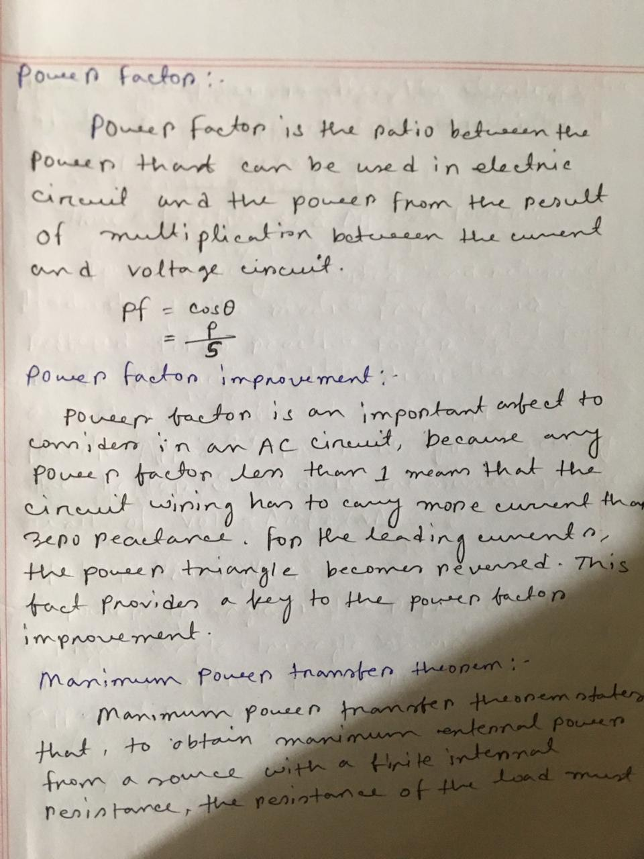

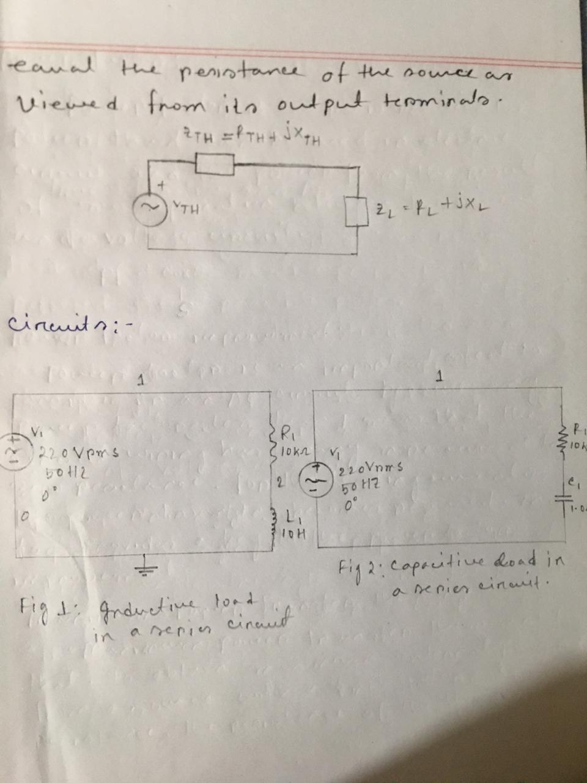

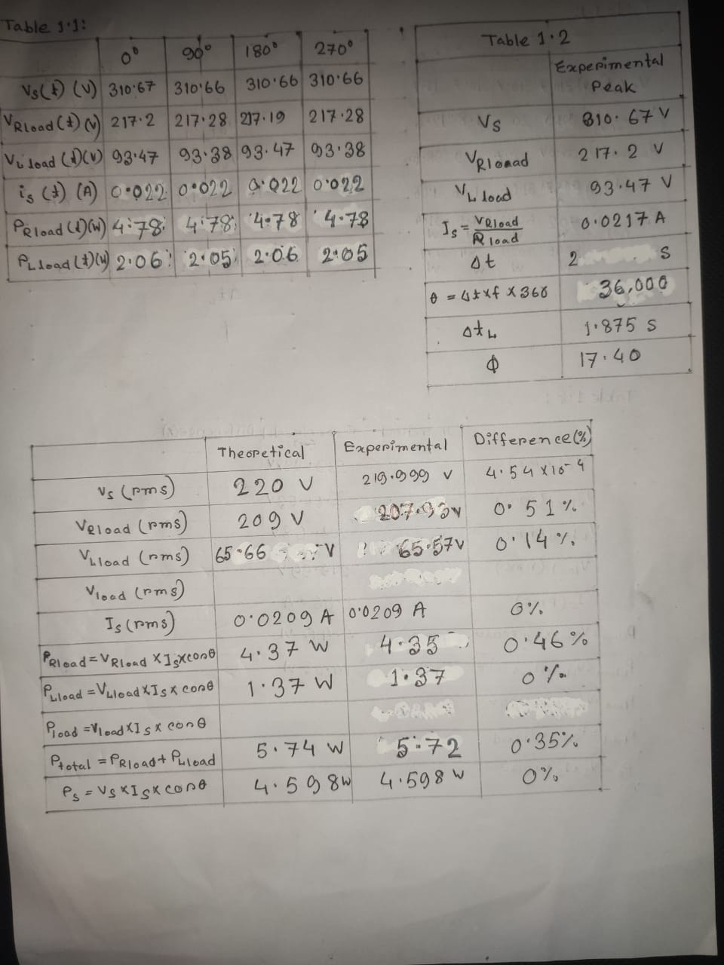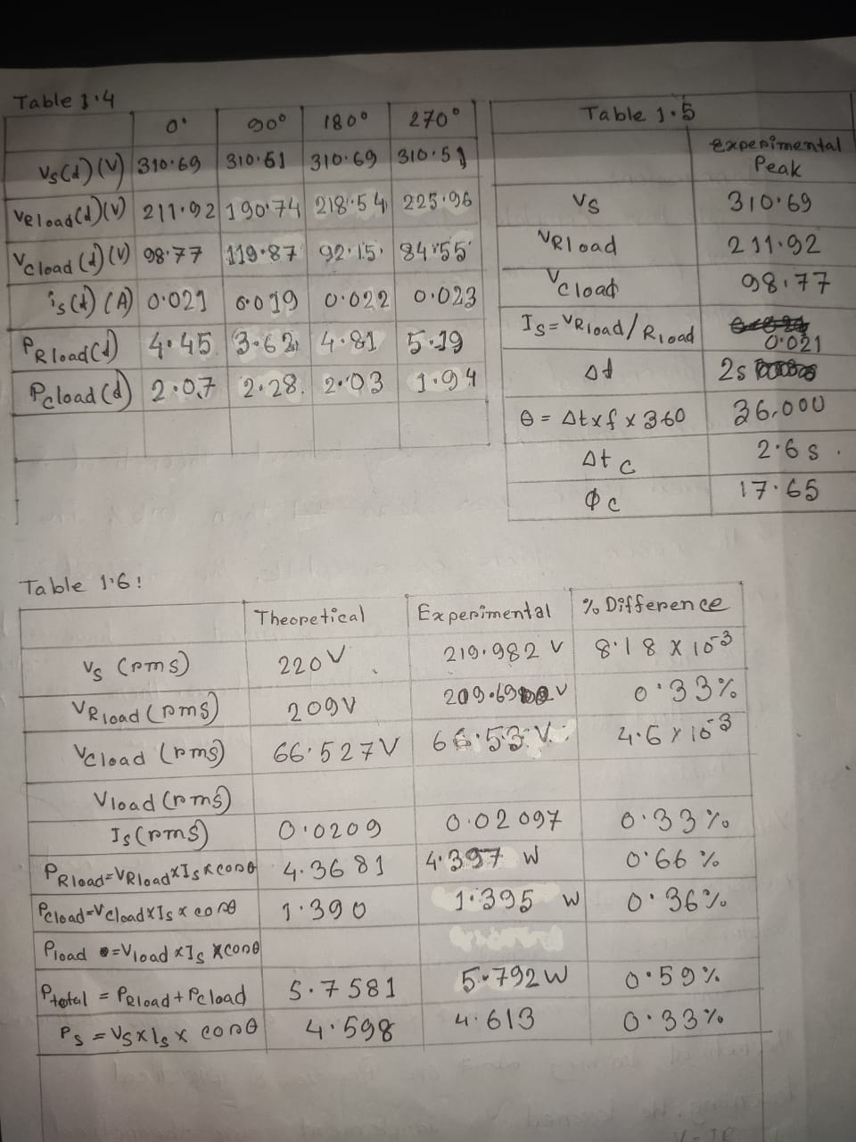

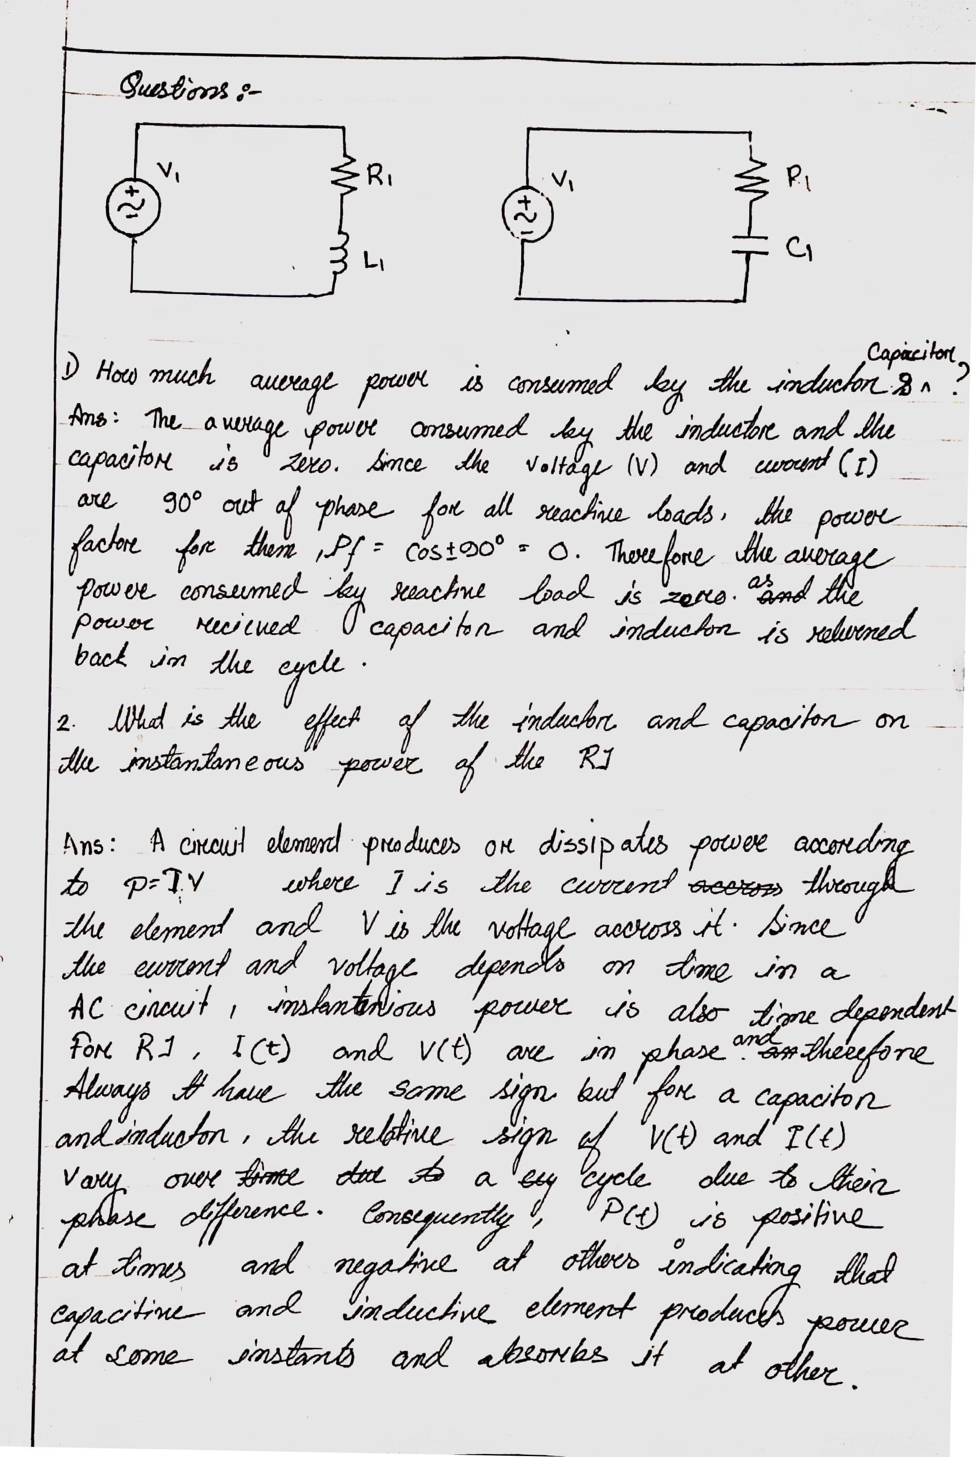

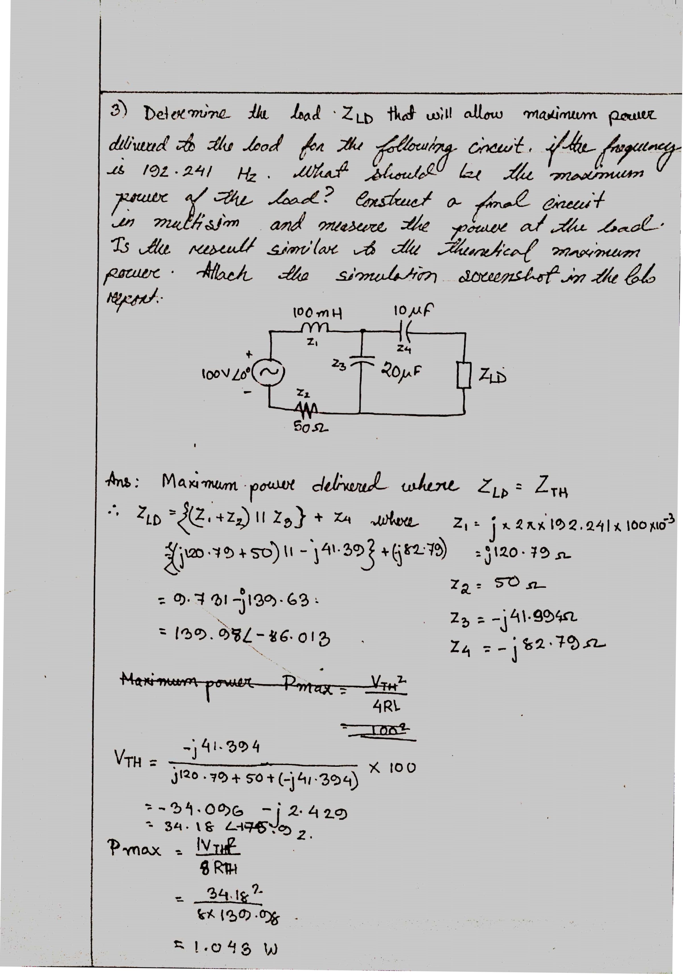Scanned with CamScanner

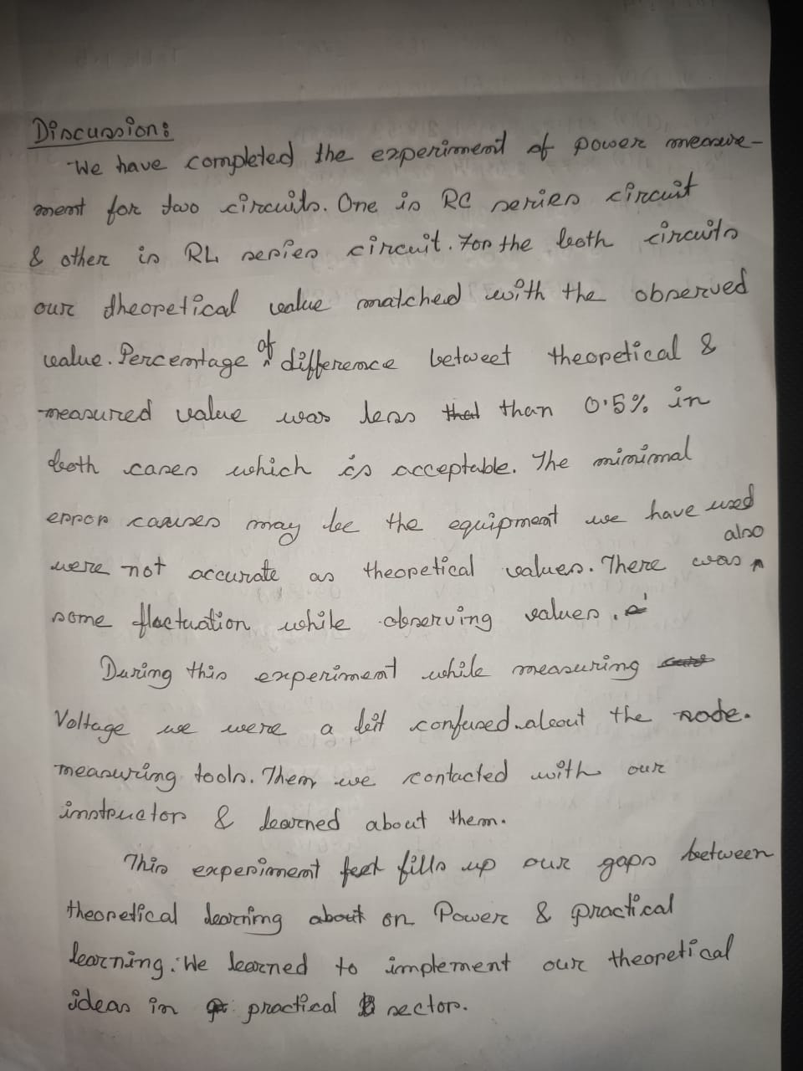

Measuring Del-Tc and V(load) across Capacitor at 0 Degree Phase shift

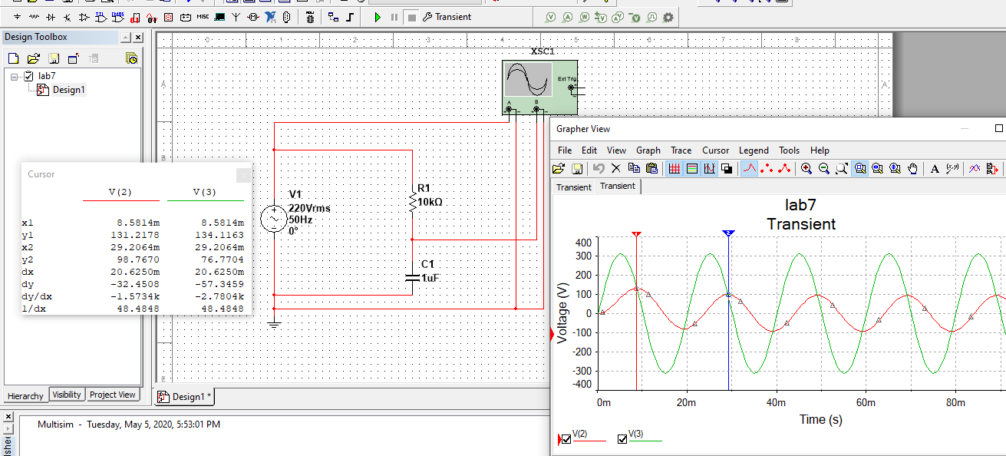

Measuring Del-Tc and V(source) across Capacitor at 0 Degree Phase shift

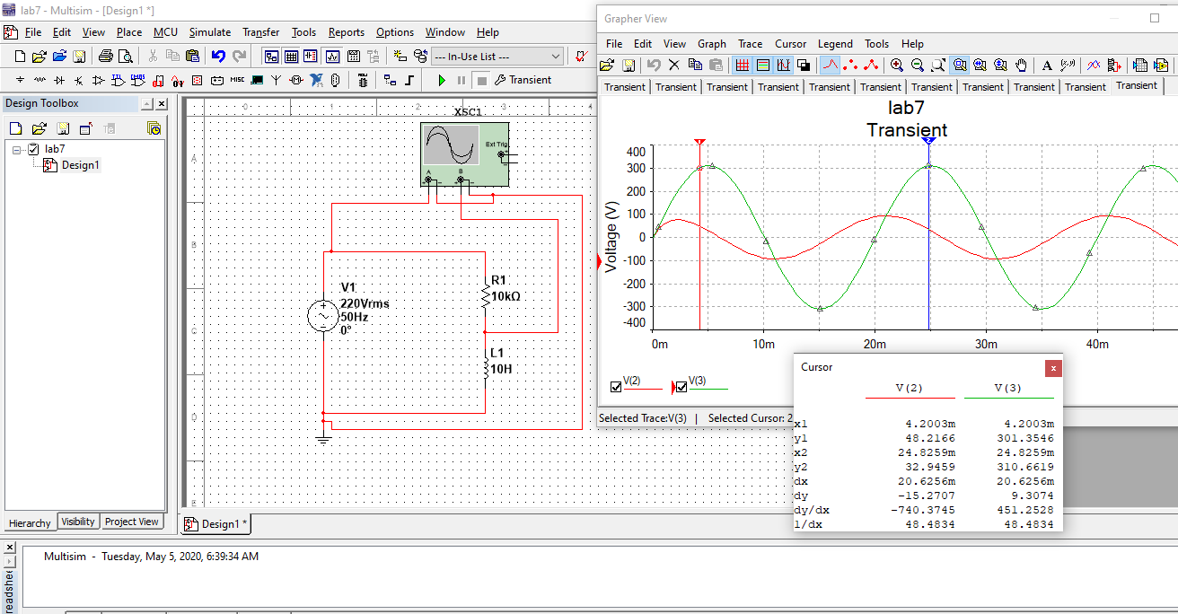

Measuring Source RMS Current in RL series circuit, I(source)

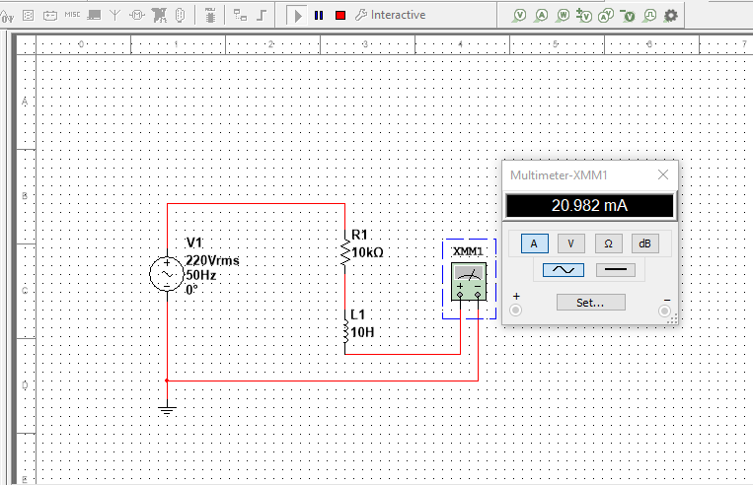

Measuring Source RMS Current in RC series circuit, I(source)

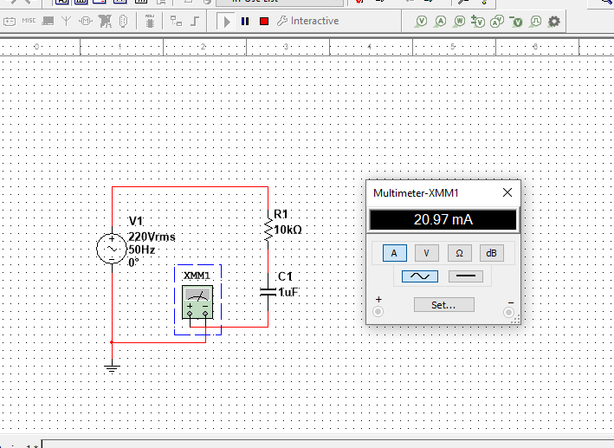

Measuring Source RMS Voltage across Resistor and Capacitor, I(source)

